B.Tech. BCSE497J - Project-I

INTELLIGENT INVESTIGATIVE INTERVIEW ASSISTANT USING SPEECH EMOTION ANALYSIS, COMPUTER VISION AND LARGE LANGUAGE MODELS

Submitted in partial fulfillment of the requirements for the degree of

Bachelor of Technology

in

Computer Science and Engineering

by

23BCE2201 | AJMAL SADHIQ
23BCE2216 | GARVIT KOHLI
23BCE2221 | ANIKET AGRAWAL

Under the Supervision of
Dr.Sivaprakash S
Associate Professor Grade 1
School of Computer Science and Engineering (SCOPE)



October 2026

DECLARATION

I hereby declare that the project entitled Intelligent Investigative Interview Assistant Using Speech Emotion Analysis, Computer Vision and Large Language Models submitted by me, for the award of the degree of Bachelor of Technology in Computer Science and Engineering to VIT is a record of bonafide work carried out by me under the supervision of Prof. / Dr. Sivaprakash S
I further declare that the work reported in this project has not been submitted and will not be submitted, either in part or in full, for the award of any other degree or diploma in this institute or any other institute or university.

Place : Vellore Date :
Signature of the Candidate

CERTIFICATE

This is to certify that the project entitled Intelligent Investigative Interview Assistant Using Speech Emotion Analysis, Computer Vision and Large Language Models submitted by Ajmal Sadhiq(23BCE2201), Garvit Kohli(23BCE2216), Aniket Agrawal(23BCE2221), School of Computer Science and Engineering, VIT, for the award of the degree of Bachelor of Technology in Computer Science and Engineering, is a record of bonafide work carried out by him / her under my supervision during Fall Semester 2024-2025, as per the VIT code of academic and research ethics.

The contents of this report have not been submitted and will not be submitted either in part or in full, for the award of any other degree or diploma in this institute or any other institute or university. The project fulfills the requirements and regulations of the University and in my opinion meets the necessary standards for submission.

Place : Vellore
Date :

Signature of the Guide

Examiner(s)

Dr. Boominathan P
Computer Science and Engineering
ACKNOWLEDGEMENTS

I am deeply grateful to the management of Vellore Institute of Technology (VIT) for providing me with the opportunity and resources to undertake this project. Their commitment to fostering a conducive learning environment has been instrumental in my academic journey. The support and infrastructure provided by VIT have enabled me to explore and develop my ideas to their fullest potential.

My sincere thanks to Dr. Jaisankar N, the Dean of the School of Computer Science and Engineering (SCOPE), for his unwavering support and encouragement. His leadership and vision have greatly inspired me to strive for excellence. The Dean’s dedication to academic excellence and innovation has been a constant source of motivation for me. I appreciate his efforts in creating an environment that nurtures creativity and critical thinking.

I express my profound appreciation to Dr. Boominathan P the Head of the School of Computer Science and Engineering (SCOPE), for his insightful guidance and continuous support. His expertise and advice have been crucial in shaping the direction of my project. The Head of Department’s commitment to fostering a collaborative and supportive atmosphere has greatly enhanced my learning experience. His constructive feedback and encouragement have been invaluable in overcoming challenges and achieving my project goals.

I am immensely thankful to my project guide, Dr. Sivaprakash S, for his dedicated mentorship and invaluable feedback. His patience, knowledge, and encouragement have been pivotal in the successful completion of this project. My supervisor’s willingness to share his expertise and provide thoughtful guidance has been instrumental in refining my ideas and methodologies. His support has not only contributed to the success of this project but has also enriched my overall academic experience.

Thank you all for your contributions and support.

Ajmal Sadhiq(23BCE2201), Garvit Kohli(23BCE2216), Aniket Agrawal(23BCE2221)

TABLE OF CONTENTS

Sl.No | Contents | Page No.
 | Abstract | i
1. | INTRODUCTION | 1
 | 1.1 Background | 1
 | 1.2 Motivations | 1
 | 1.3 Scope Of The Project | 1
2. | PROJECT DESCRIPTION AND GOALS | 2
 | 2.1 Literature Review | 2
 | 2.2 Research Gap | 2
 | 2.3 Objectives | 3
 | 2.4 Problem Statement | 3
 | 2.5 Project Plan | 3
3. | TECHNICAL SPECIFICATION | 4
 | 3.1 Requirements | 4
 | 3.1.1 Functional | 4
 | 3.1.2 Non-Functional | 4
 | 3.2 Feasibility Study | 4
 | 3.2.1 Technical Feasibility | 4
 | 3.2.2 Economic Feasibility | 5
 | 3.2.2 Social Feasibility | 5
 | 3.3 System Specification | 5
 | 3.3.1 Hardware Specification | 5
 | 3.3.2 Software Specification | 6
4. | DESIGN APPROACH AND DETAILS | 7
 | 4.1 System Architecture | 7
 | 4.2 Design | 7
 | 4.2.1 Data Flow Diagram | 7
 | 4.2.2 Use Case Diagram | 8
 | 4.2.3 Class Diagram | 8
 | 4.2.4 Sequence Diagram | 9
5. | METHODOLOGY AND TESTING | 10
 | 5.1 Interview and Consent Module | 10
 | 5.2 Offline Speech Module | 10
 | 5.3 Computer Vision Module | 10
 | 5.4 Conversational AI Module | 10
 | 5.5 Reporting Module | 10
 | 5.6 Testing | 11
6. | PROJECT DEMONSTRATION | 12
 | 6.1 Demonstration Procedure | 12
 | 6.2 Airport Interview Scenario | 12
 | 6.3 Visa-Office Interview Scenario | 12
 | 6.4 Offline Operation | 12
7. | RESULT AND DISCUSSION (COST ANALYSIS as applicable) | 13
 | 7.1 Implementation Results | 13
 | 7.2 Discussion | 13
 | 7.3 Current Limitations | 13
8. | CONCLUSION | 15
 | 8.1 Conclusion | 15
 | 8.2 Future Work | 15
9. | REFERENCES | 16
 | APPENDIX A – SAMPLE CODE | 17
 | A.1 Local Model Configuration | 17
 | A.2 Local faster-whisper Service | 17
 | A.3 Audio Upload and Temporary-file Deletion | 18

List of Figures

Figure No. | Title | Page No.
4.1 | System architecture of the immigration interview assistant | 7
4.2 | Interview Data Flow | 7
4.3 | Immigration Interview Use Cases | 8
4.4 | Interview Class Design | 8
4.5 | Interview Sequence | 9

List of Tables

Table No. Title Page No.
2.1 Literature Review 2
2.2 Project Objectives 3
3.1 Functional Requirements 4
3.2 Software Specifications 6
5.1 Backend Verification Results 11
7.1 Implemented Capability Summary 13

List of Abbreviations

AI Artificial Intelligence
API Application Programming Interface
ASR Automatic Speech Recognition
CV Computer Vision
DFD Data Flow Diagram
LLM Large Language Model
NIST National Institute of Standards and Technology
PII Personally Identifiable Information
STT Speech-To-Text
TRL Technology Readiness Level
UI User Interface

Symbols and Notations

WER | Word Error Rate
CER | Character Error Rate
t_s | Interview start time
t_e | Interview end time
Δt | Response or processing latency
N_T | Number of transcript statements
N_Q | Number of generated questions
N_O | Number of recorded observations
C_T | Speech-transcription confidence
C_O | Facial-observation detection strength
1 | Exactly 1 associated record
0..1 | 0 or one associated record
0..* | 0 or more associated records
(Solid arrow) | Primary data or control flow
Diamond | Aggregation or ownership relationship in the class diagram
Dashed arrow | Returned response, supporting context or dependency

ABSTRACT

Immigration interviews require authorized officers to examine travel plans, visa applications, supporting documents and verbal responses within a limited period. Language differences, incomplete information, inconsistent documentation and noisy interview environments can reduce the clarity of the record. This project develops an AI-assisted immigration interview system for airport, border-entry, visa-office and consular settings. The system supports the officer by creating a multilingual transcript, proposing neutral context-aware questions and preparing a structured report while preserving human responsibility for all official decisions. The prototype uses React and Vite for the browser interface, FastAPI for the application service, SQLAlchemy with SQLite for local records, faster-whisper for offline multilingual speech recognition, MediaPipe Face Landmarker for local facial-movement observations and Qwen3 14B through Ollama for question and report generation. The officer selects an airport or visa-office context, chooses the interview language and records consent before capture. The browser records short audio segments, the backend transcribes each segment locally and deletes the temporary audio file after processing. The LLM receives the interview objective, prior account, transcript and earlier questions and returns a structured neutral follow-up. The report separates recorded statements, interpretations, recommended procedural follow-up and limitations. The current implementation supports international languages, local model execution and offline PDF saving after one-time model installation. Automated backend tests verify consent enforcement, interview lifecycle operations, audio-segment handling, transcript storage, facial-observation association, question generation and report generation. Four backend tests pass, and the frontend production build completes successfully. These results verify software functionality rather than real-world immigration accuracy. The prototype does not verify passports or visas and does not determine deception, admissibility, visa eligibility or immigration status. Future work requires multilingual accuracy evaluation, domain-expert assessment, security controls, document-verification integration and fairness testing before any operational pilot.

CHAPTER 1
1.1 INTRODUCTION

1.1 Background

Immigration interviews occur at airports, border-entry points, visa offices and consulates. Officers use these interviews to clarify travel purpose, intended activities, accommodation, funding, sponsorship, application history and supporting documents. The interview record must preserve the applicant or traveler’s own account and distinguish that account from information obtained from documents or external systems.
Modern border-processing systems already use machine-readable travel documents, passenger information and biometric identity verification. However, these systems do not automatically solve communication and documentation problems within a live interview. Officers may work across several languages, accents and dialects, and a continuous internet connection may be unavailable or inappropriate for sensitive information. A locally deployable assistant can support transcription and question preparation without transferring interview content to a cloud service.

1.2 Motivation
The project is motivated by the need for accurate multilingual records, consistent questioning and transparent human oversight. Speech recognition can reduce manual note-taking, while an LLM can identify unanswered topics from the transcript. These technologies also introduce risks. Transcription errors may alter meaning, LLMs may invent facts, and facial observations may be misinterpreted. The system therefore treats AI output as reviewable assistance rather than evidence or a decision.

  - Scope of the project
- Airport and border-entry interviews involving travel purpose, itinerary, accommodation, duration, declarations and onward or return travel.
- Visa-office and consular interviews involving application purpose, intended study or employment, funding, sponsorship, application history and supporting documents.
- Offline multilingual transcription with faster-whisper after local model installation.
- Neutral follow-up generation and structured reports with Qwen3 14B through Ollama.
- Local transcript storage in SQLite and local PDF saving through the browser.
- Experimental facial-movement observations that cannot establish emotion, deception or immigration eligibility.

The project excludes automated approval, refusal, admission, detention, removal and document-authenticity decisions. It also excludes any inference based on nationality, race, ethnicity, religion, gender, disability, accent or language.
CHAPTER 2
2.1 Literature Review
Table 2.1 Literature Review
Paper | Objective | Methodology | Pros and Cons | Findings
Digital Gatekeepers (2025) | Examine LLM use and fairness in immigration decisions | Choice experiments and interviews | Immigration-specific; reports bias risk | Human oversight remains necessary
Whisper (2022) | Develop robust multilingual ASR | 680,000 hours of multilingual and multitask supervision | Broad language support; accuracy varies | Strong zero-shot speech recognition
Qwen3 (2025) | Improve multilingual generation and reasoning | Dense and mixture-of-experts model evaluation | Local deployment; output may be wrong | Supports multilingual structured generation
NIST FRTE Demographic Effects (2019) | Measure demographic differences in face recognition | Large-scale algorithm evaluation | Independent study; not emotion analysis | Performance varies by algorithm and image quality

The literature shows that multilingual ASR and LLMs can support administrative work, while immigration-specific research warns against allowing models to make high-impact decisions. ICAO guidance emphasizes identity evidence, travel-document integrity and inspection systems. NIST evaluations show that biometric performance depends on image quality and demographic conditions. These findings support a narrow design in which the system records and organizes information while the officer independently verifies documents and applies immigration procedure.

2.2 Research Gap
- Existing border systems concentrate on identity and document verification rather than multilingual conversational assistance.
- Cloud speech services may create privacy and connectivity constraints for sensitive interviews.
- Few systems connect the live transcript, prior account and earlier questions when suggesting a follow-up.
- AI recommendations often lack a clear separation between recorded facts, interpretation and procedural follow-up.
- Published model performance does not guarantee equal accuracy across languages, accents, dialects and code-switching.

2.3 Objectives
Table 2.2 Project Objectives
No. | Objective
1 | Support airport and visa-office interview modes.
2 | Transcribe major Indian and international languages locally.
3 | Generate one neutral, non-repetitive question from the current record.
4 | Store transcripts, questions and reports in a structured local database.
5 | Generate reports that distinguish observations, interpretations, recommendations and limitations.
6 | Keep every immigration decision under authorized human control.

2.4 Problem Statement
There is a need for a multilingual, locally deployable assistant that helps immigration officers record interviews and identify unresolved travel or application details without automating admissibility or visa decisions. The system must function offline after model preparation, preserve consent and data-minimization controls, and make uncertainty visible at every stage.

2.5 Project Plan
1. Define immigration interview scope and safety boundaries.
2. Implement consent, interview lifecycle and local data storage.
3. Integrate international-language transcription and local vision assets.
4. Integrate Qwen3 14B for structured questions and reports.
5. Validate software workflow and document known limitations.
6. Evaluate language accuracy, question relevance, fairness and security before any pilot.

CHAPTER 3
3.1 Requirements
3.1.1 Functional
Table 3.1 Functional Requirements
ID | Requirement | Priority
FR1 | Create airport or visa-office interview | Required
FR2 | Capture explicit consent before device access | Required
FR3 | Select an international interview language | Required
FR4 | Transcribe short audio segments locally | Required
FR5 | Allow manual transcript correction | Required
FR6 | Generate neutral context-aware questions | Required
FR7 | Store interview records in SQLite | Required
FR8 | Generate a structured final report | Required
FR9 | Save the report locally as PDF | Required
FR10 | Prevent automated immigration conclusions | Required

3.1.2 Non-Functional
- Privacy: raw audio and video are not retained by default; temporary audio is deleted after transcription.
- Availability: normal runtime works without an active internet connection after model installation.
- Usability: capture indicators, consent state and interview status remain visible.
- Explainability: reports separate recorded, interpreted, recommended and limitation sections.
- Safety: prompts prohibit deception, admissibility and protected-trait conclusions.
- Maintainability: frontend, API, transcription, LLM and database concerns remain modular.

3.2 Feasibility study
3.2.1 Technical Feasibility
The prototype runs on a Windows development computer using React, FastAPI, SQLite, faster-whisper, MediaPipe and Ollama. Qwen3 14B is installed locally. CPU transcription is supported by using int8 computation, while GPU acceleration can be configured on compatible hardware. No paid cloud API is required for normal operation.

3.2.2 Economic Feasibility
The principal software components are open source or locally available. The prototype therefore avoids recurring cloud inference charges. The main costs are development time, storage for local models and suitable computing hardware. Operational deployment would add security assessment, maintenance, governance and staff-training costs.

3.2.3 Social Feasibility
Immigration decisions can have serious consequences. The assistant must not rank applicants, infer deception or rely on protected characteristics. Officers must disclose capture, obtain appropriate consent, verify transcripts and use approved procedures. Accessibility, language equity and the right to correction require evaluation before deployment.

3.3 System Specifications
3.3.1 Hardware Specifications
- 64-bit Windows computer with at least 16 GB RAM recommended for Qwen3 14B.
- Approximately 12 GB free storage for the LLM, Whisper model and application assets.
- Microphone and webcam for interview capture.
- Optional NVIDIA GPU for faster transcription and LLM inference.

3.3.2 Software Specifications
Table 3.2 Software Specifications
Layer | Technology | Purpose
Frontend | React and Vite | Interview setup, live workspace and report view
Backend | FastAPI | REST endpoints, lifecycle and orchestration
Database | SQLite and SQLAlchemy | Local structured interview records
Speech | faster-whisper Small | Offline multilingual transcription
Vision | MediaPipe Face Landmarker | Local facial-movement observations
LLM | Ollama Qwen3:14B | Neutral questions and structured reports

CHAPTER 4
4.1 System architecture
Architecture keeps interview capture, local processing and human review separate. Audio crosses only the localhost boundary. Video frames remain in the browser. The backend stores transcript text and derived observations, and the LLM receives only the structured interview context required for a question or report.

Figure 4.1 System Architecture
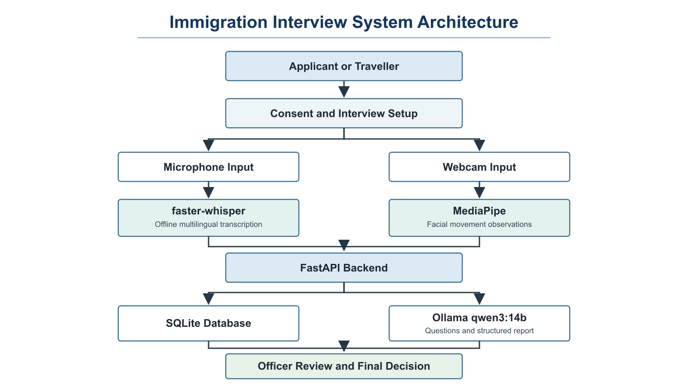
4.2 Design
4.2.1 Data Flow Diagram
Figure 4.2 Interview Data Flow
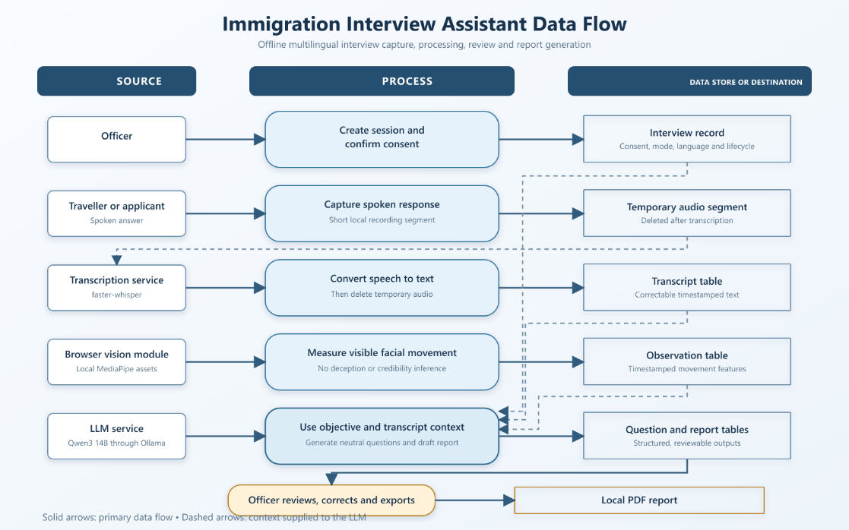

4.2.2 Use Case Diagram
Figure 4.3 Immigration Use Cases
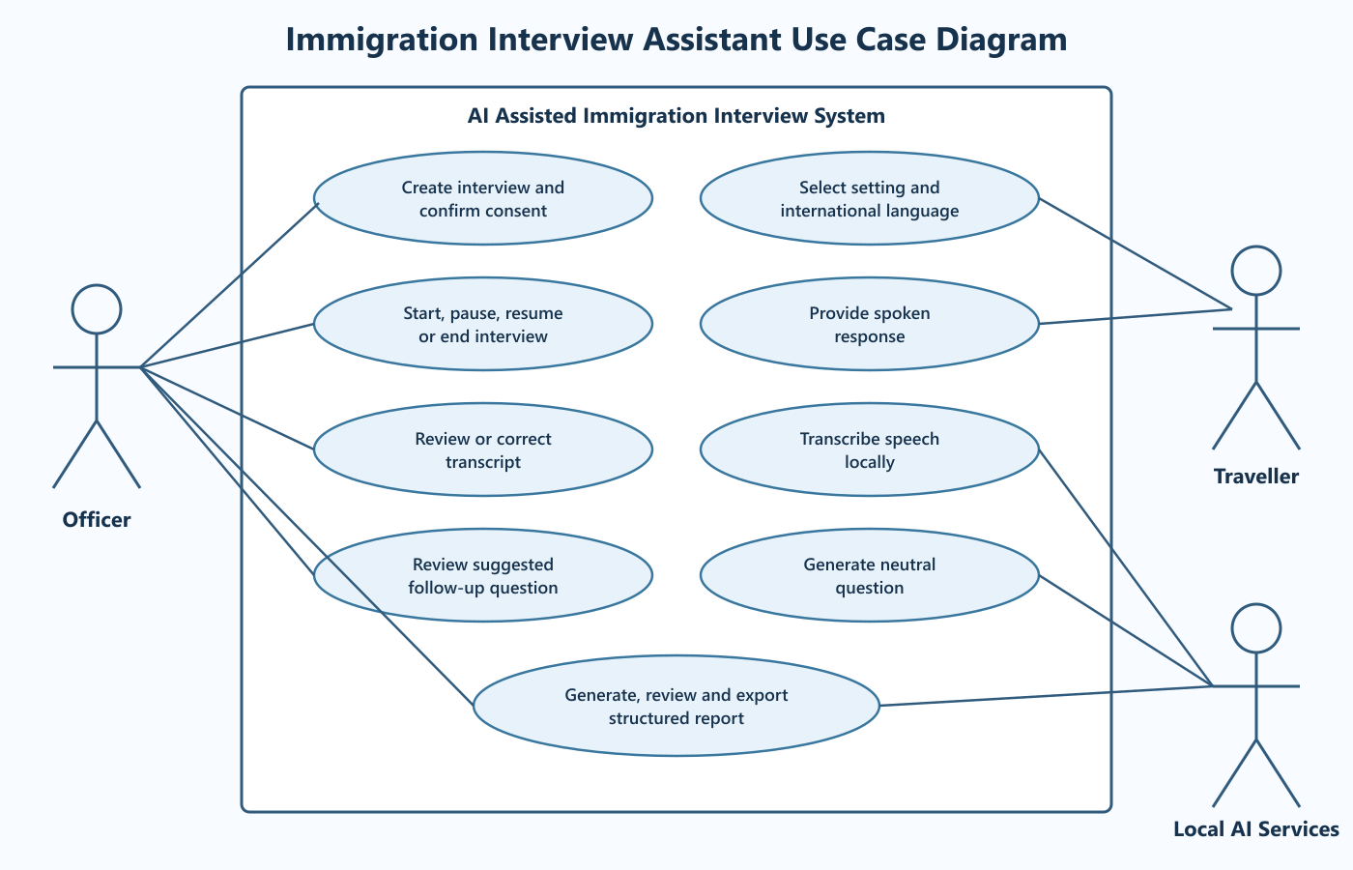

4.2.3 Class Diagram
Figure 4.4 Interview Class Design
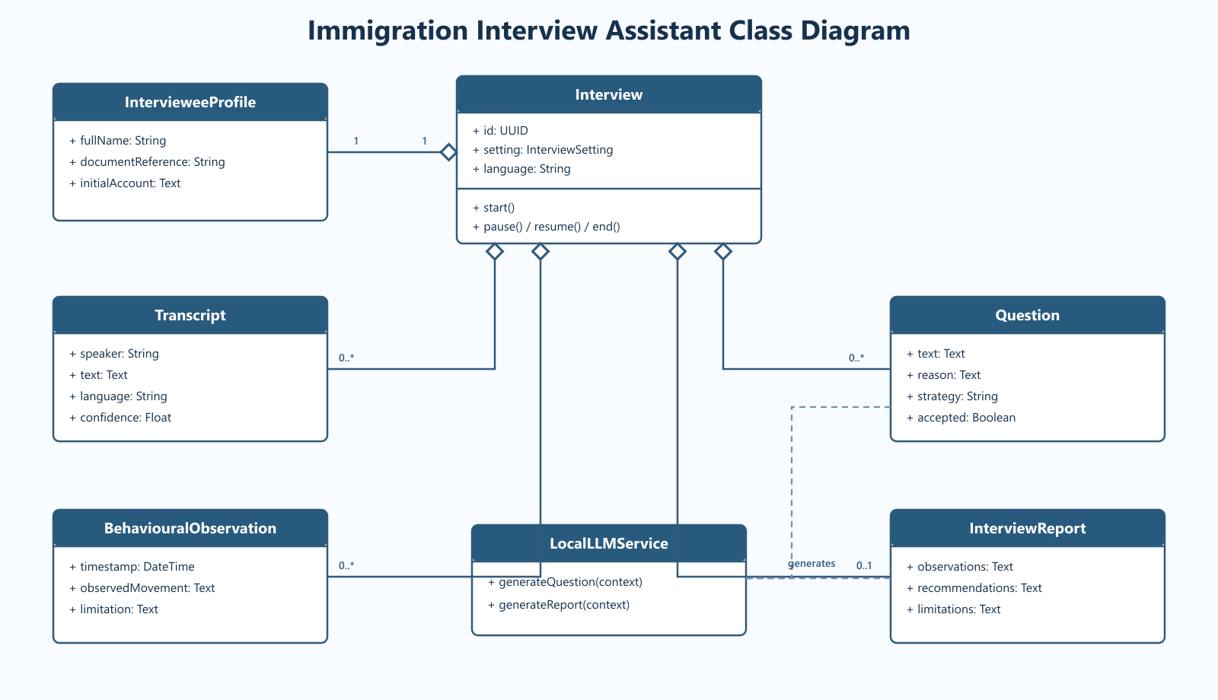

4.2.4 Sequence Diagram
Figure 4.5 Interview Sequence
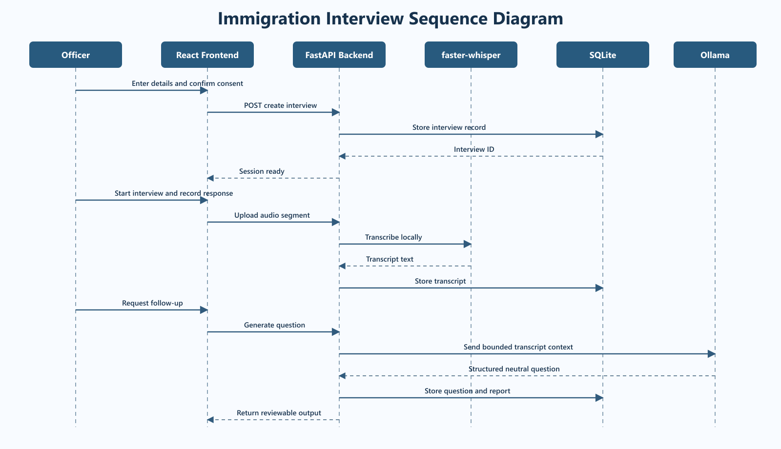

CHAPTER 5
5.1 Interview and Consent Module
The interface requires the officer to choose an interview setting and language, enter the applicant or traveler’s basic information, record an initial summary and confirm consent. The backend rejects interview creation when consent is false. Lifecycle transitions restrict transcription and observations to an active interview.

5.2 Offline Speech Module
The browser Media Recorder produces independent audio segments. The backend validates each upload, writes it to a temporary file and runs faster-whisper with a language hint. Only the resulting text, selected language and confidence value are stored. The temporary file is deleted whether transcription succeeds or fails.

5.3 Computer Vision Module
MediaPipe Face Land marker runs from locally bundled Web Assembly and model files. It identifies facial blend shape activity and produces descriptive movement patterns. The interface labels expression estimates as heuristic and prohibits their use as evidence of emotion, truthfulness, intent or eligibility.

5.4 Conversational AI Module
Qwen3:14B runs locally through Ollama. The backend supplies the interview objective, selected language, initial account, transcript history and previous questions. A JSON schema constrains the response to a question, reason and strategy. The prompt prohibits invented facts, repeated questions, protected-trait inferences and automated immigration conclusions.

5.5 Reporting Module
After the interview ends, the backend combines saved statements, questions, observations and intake data. The model produces observed, interpreted, recommended and limitation sections. Deterministic analytics calculate statement count, word count, question count, duration and observation summaries. The browser uses the operating system print dialog to save the report as a PDF while offline.

5.6 Testing
Figure 5.1 Backend and Frontend Verification
Test | Procedure | Expected Result | Status
Consent gate | Create interview without consent | HTTP 422 | Passed
Interview lifecycle | Start and end a valid interview | Valid status transitions | Passed
Offline audio route | Upload local audio segment | Transcript saved and temporary file deleted | Passed
Transcript storage | Save and retrieve statement | Text returned in chronological order | Passed
Observation association | Store facial observation | Associated with latest statement | Passed
Question endpoint | Generate contextual question | Structured response stored | Passed
Report endpoint | Generate report after interview | Structured report and analytics returned | Passed
Frontend build | Run production build | Build completes | Passed

CHAPTER 6
6.1 Demonstration Procedure
1. Start Ollama and the FastAPI backend, then start the Vite frontend.
2. Choose Airport or Border Entry, or Visa Office or Consulate.
3. Select an international language and complete the applicant or traveler intake.
4. Confirm consent and create the interview.
5. Check the camera and microphone and start the interview.
6. Record a spoken response and verify the local transcript.
7. Correct the transcript manually if required.
8. Generate a follow-up question and review it before asking.
9. End the interview and generate the structured report.
10. Use Print or Save PDF to retain the report locally.

6.2 Airport Interview Scenario
A traveler states that the purpose of travel is a two-week visit and provides a hotel destination. The system should avoid asking for the same purpose or duration again. A suitable follow-up may clarify planned activities, onward or return travel, funding, or a supporting document that the traveler has not yet described. The question remains neutral and does not presume unauthorized work or overstay.

6.3 Visa-Office Interview Scenario
A student-visa applicant describes the intended course and educational institution. The system may identify unresolved funding, accommodation, previous application or supporting-document details. It must not decide whether the applicant qualifies for the visa and must not infer credibility from accent, facial movement or nationality.

6.4 Offline Operation
After the one-time installation of frontend packages, Python dependencies, the Whisper model, local MediaPipe assets and Qwen3:14B, the runtime does not require internet access. The browser communicates with localhost services, SQLite stores the record locally and the operating system creates the PDF report.

CHAPTER 7
7.1 Implementation Results
Table 7.1 Implemented Capability Summary
Capability | Implementation Status | Evidence
Airport interview mode | Implemented | Setting-specific objective and UI
Visa-office interview mode | Implemented | Setting-specific objective and UI
International language list | Implemented | Backend configuration and selector
Offline transcription | Implemented | faster-whisper endpoint and dependency
Local LLM | Implemented | Ollama Qwen3:14B configuration
Local vision assets | Implemented | Bundled MediaPipe WASM and model
Structured report | Implemented | Report endpoint and printable report view
Automated software tests | 4 passed | Pytest workflow
Production frontend build | Successful | Vite build

7.2 Discussion
The verified results show that the application components integrate successfully into a controlled environment. They do not measure word error rate, multilingual fairness, facial-analysis validity or operational interview quality. The confidence value attached to an automatically transcribed statement primarily reflects language identification in the current implementation and must not be interpreted as certainty that every word is correct.
The shift from a general investigative interview assistant to an immigration interview assistant improves domain relevance but raises the impact of errors. Questions can affect how an applicant explains important facts. The system therefore constrains the LLM to neutral clarification, exposes the transcript for correction and prevents automated immigration conclusions. A deployment decision would require legal review, security assessment, accessibility testing and evaluation with representative languages and interview conditions.

7.3 Current Limitations
- No passport, visa or supporting-document authenticity verification.
- No operational dataset or field evaluation in an airport or visa office.
- Transcription accuracy has not yet been measured across supported languages.
- LLM question relevance has not yet been rated by immigration-domain experts.
- Facial-expression estimates remain experimental and may introduce bias or distraction.
- Authentication, encryption, access control and retention automation require further work.
- Local Qwen3:14B inference may be slow on computers without adequate memory or GPU acceleration.

CHAPTER 8
8.1 Conclusion
The project delivers a laboratory-validated prototype for multilingual immigration interviews at airports and visa offices. It combines local speech transcription, an interview lifecycle, reviewable computer-vision observations, context-aware neutral questions, persistent local records and a structured report. The architecture supports offline use after model preparation and avoids routine transfer of sensitive interview content to external services.
The prototype demonstrates software integration rather than decision accuracy. It does not determine deception, admissibility, visa eligibility or immigration status. The officer remains responsible for verifying the transcript, reviewing documents, applying approved procedure and making every official decision.

8.2 Future Work
- Measure word error rate for representative international languages, accents, dialects and code-switching.
- Evaluate question relevance, neutrality and repetition with immigration-domain experts.
- Add optional local translation while preserving the original-language transcript.
- Integrate authorized travel-document verification through approved systems.
- Implement authentication, role-based access, encryption, audit logging and retention controls.
- Conduct fairness and accessibility studies before any field pilot.
- Compare performance with and without facial analysis and remove it if it does not provide safe, useful assistance.
- Prepare a Scopus-indexed conference paper after completing empirical evaluation.

CHAPTER 9
9. REFERENCES

- Y. Mao and Y. Zhao, "Digital Gatekeepers: Exploring Large Language Model's Role in Immigration Decisions," arXiv preprint arXiv:2506.21574, 2025.
- International Civil Aviation Organization, "Traveller Identification Programme Strategy," ICAO, Montreal, Canada. [Online]. Available: https://www.icao.int/CDI/ipack-implementing-icao-trip-strategy-roadmap
- International Civil Aviation Organization, "ICAO Public Key Directory: Frequently Asked Questions," ICAO, Montreal, Canada. [Online]. Available: https://www.icao.int/icao-pkd/frequently-asked-questions
- International Civil Aviation Organization, "API Guidelines and PNR Reporting Standards," ICAO, Montreal, Canada. [Online]. Available: https://www.icao.int/facilitation-programmes/api-guidelines-and-pnr-reporting-standards
- P. Grother, M. Ngan, and K. Hanaoka, "Face Recognition Vendor Test Part 3: Demographic Effects," National Institute of Standards and Technology, Gaithersburg, MD, USA, NISTIR 8280, Dec. 2019.
- A. J. O'Toole, P. J. Phillips, X. An, and J. Dunlop, "Demographic Effects on Estimates of Automatic Face Recognition Performance," National Institute of Standards and Technology, Gaithersburg, MD, USA, NISTIR 7757, Mar. 2011.
- A. Radford, J. W. Kim, T. Xu, G. Brockman, C. McLeavey, and I. Sutskever, "Robust Speech Recognition via Large-Scale Weak Supervision," arXiv preprint arXiv:2212.04356, 2022.
- SYSTRAN, "faster-whisper: Faster Whisper Transcription with CTranslate2," GitHub repository, 2026. [Online]. Available: https://github.com/SYSTRAN/faster-whisper
- A. Yang et al., "Qwen3 Technical Report," arXiv preprint arXiv:2505.09388, 2025.
- Google AI, "MediaPipe Face Landmarker," Google AI Edge Documentation, 2026. [Online]. Available: https://ai.google.dev/edge/mediapipe/solutions/vision/face_landmarker

APPENDIX A – Sample Code
A.1 Local Model Configuration
DATABASE_URL=sqlite:///./interview_assistant.db
OFFLINE_MODE=true
PERSIST_RAW_MEDIA=false
LLM_PROVIDER=ollama
LLM_BASE_URL=http://localhost:11434/v1
LLM_MODEL=qwen3:14b
WHISPER_MODEL_PATH=models/whisper/small
WHISPER_DEVICE=cpu
WHISPER_COMPUTE_TYPE=int8

A.2 Local faster-whisper Service
@lru_cache(maxsize=1)
def _model():
from faster_whisper import WhisperModel
model_path = Path(settings.whisper_model_path)
if not model_path.is_absolute():
model_path = Path(__file__).resolve().parents[3] / model_path
if not model_path.exists():
raise RuntimeError('Offline Whisper model was not found')
return WhisperModel(
str(model_path),
device=settings.whisper_device,
compute_type=settings.whisper_compute_type,
local_files_only=True,
)
def transcribe_audio(audio_path: str, selected_language: str) -> dict:
language = LANGUAGE_BY_NAME.get(selected_language)
segments, info = _model().transcribe(
audio_path,
language=language['code'] if language else None,
beam_size=5,
vad_filter=True,
condition_on_previous_text=False,
)
text = ' '.join(s.text.strip() for s in segments if s.text.strip()).strip()
return {
'text': text,
'detected_language': info.language,
'language_probability': float(info.language_probability),
}

A.3 Audio Upload and Temporary-file Deletion
@app.post('/api/interviews/{interview_id}/audio-segments', status_code=201)
async def transcribe_audio_segment(interview_id: int, audio: UploadFile,
language: str, db: Session = Depends(get_db)):
interview = require_interview(db, interview_id)
if interview.status != 'active':
raise HTTPException(409, 'Audio transcription requires an active interview')
data = await audio.read(settings.max_audio_segment_mb * 1024 * 1024 + 1)
path = None
try:
with tempfile.NamedTemporaryFile(delete=False, suffix='.webm') as temporary:
temporary.write(data)
path = temporary.name
result = await run_in_threadpool(transcribe_audio, path, language)
finally:
if path:
try:
os.unlink(path)
except FileNotFoundError:
pass
if not result['text']:
return {'saved': False, **result}
row = Transcript(interview_id=interview_id, speaker='interviewee',
text=result['text'], language=language,
confidence=result['language_probability'])
db.add(row)
db.commit()
return {'id': row.id, 'saved': True, **result}

